Financial Transactions & Loans Dashboard

Submitted by:
Name: S.SHERENE
Roll no: E25FA067
Department: B.Com FinTech and AI
Year of Study: 2nd Year

Introduction
The Dataset 4 project focuses on financial transactions, customer accounts, banking branches, and loan information. The dataset contains records related to transaction amounts and dates, transaction types, account balances and statuses, customer types, branch locations, and loan details. Microsoft Power BI can be used to combine these tables and create interactive visualizations that help examine transaction activity, account distribution, customer segments, and loan performance.
Objectives
Before starting, the dashboard analysis was planned around the following goals:
- To analyse the volume and value of financial transactions.
- To compare deposits, withdrawals, transfers, and payments.
- To examine transaction trends over time and across branches.
- To analyse account balances by account type and account status.
- To understand the distribution of customers by customer type and location.
- To evaluate loan principal, interest rates, and loan repayment status.
- To present the findings through interactive Power BI visualizations for easier interpretation.
Dataset Description
Dataset 4 is a relational banking dataset made up of CSV tables for transactions, transaction types, accounts, account types, account statuses, customers, customer types, addresses, branches, loans, and loan statuses. The transaction table contains 50,000 records, accounts contains 1,667 records, customers contains 1,111 records, loans contains 333 records, and branches contains 50 records. The remaining lookup tables describe categories and statuses used to interpret the main records.
Data Preparation
- TransactionID – uniquely identifies each transaction.
- TransactionTypeID / TypeName – identifies whether a transaction is a deposit, withdrawal, transfer, or payment.
- Amount – transaction amount used to calculate total and average transaction values.
- TransactionDate – date and time used to analyse transaction trends.
- BranchID / BranchName – identifies the branch associated with a transaction.
- AccountID, Balance, AccountType, AccountStatus – describe account details and balances.
- CustomerID, CustomerType, City, Country – support customer-segment and location analysis.
- LoanID, PrincipalAmount, InterestRate, LoanStatus – describe loan amounts, rates, and repayment status.
DAX Measures Used
- Total Transaction Amount = SUM(Transactions[Amount])
- Total Transactions = COUNTROWS(Transactions)
- Average Transaction Amount = AVERAGE(Transactions[Amount])
- Total Account Balance = SUM(Accounts[Balance])
- Number of Accounts = DISTINCTCOUNT(Accounts[AccountID])
- Number of Customers = DISTINCTCOUNT(Customers[CustomerID])
- Total Loan Principal = SUM(Loans[PrincipalAmount])
- Average Interest Rate = AVERAGE(Loans[InterestRate])
- Number of Loans = DISTINCTCOUNT(Loans[LoanID])
These measures can be used in cards, charts, and tables. Format financial amounts as currency and InterestRate as a percentage. Confirm that relationships and filter directions are correct before interpreting cross-table totals.
Dashboard Components
1. Cards
Cards can display Total Transaction Amount, Total Transactions, Average Transaction Amount, Total Account Balance, Number of Accounts, and Total Loan Principal. They provide a quick overview of the dataset.
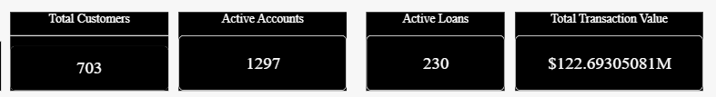
2. Transactions Over Time
A line chart using TransactionDate by month and Total Transactions or Total Transaction Amount can show changes in transaction activity over time. Missing transaction dates should be excluded from the date axis and reported as a data-quality limitation.
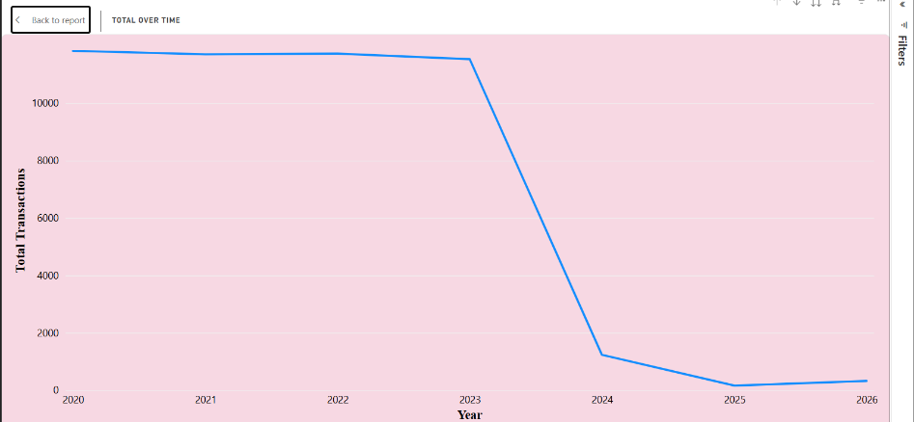
Transactions by Day
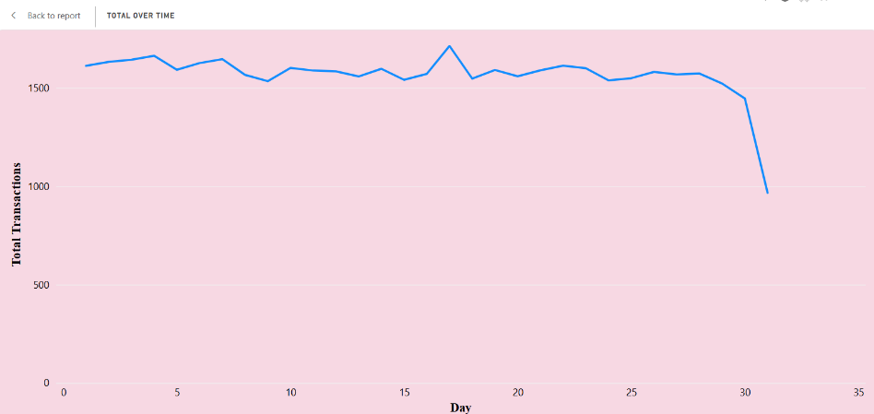
Transaction by Month
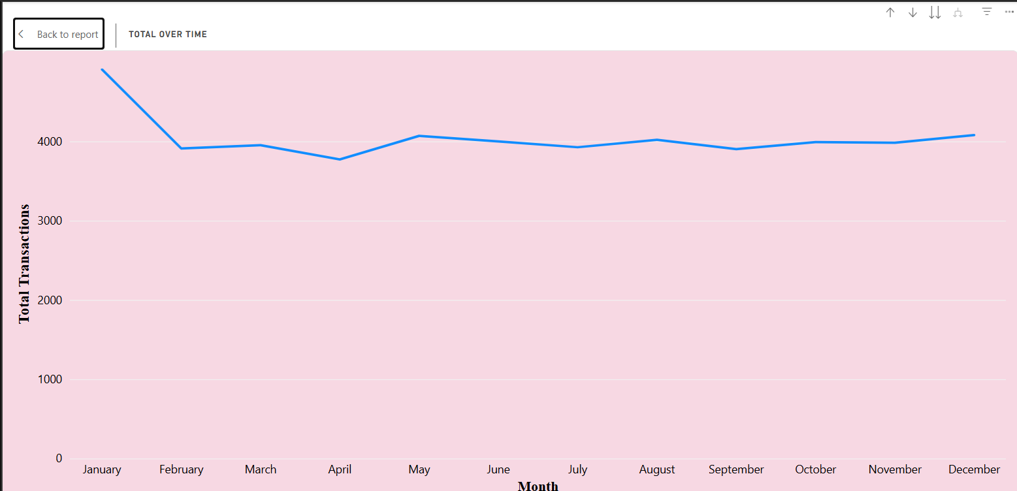
Transactions by Quarter
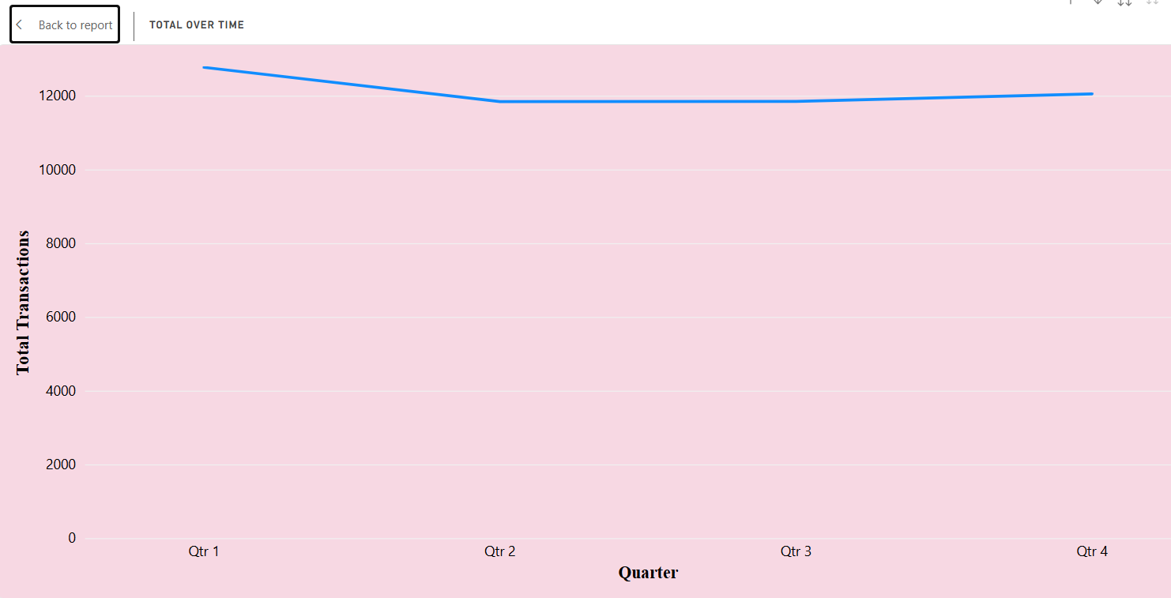

Transaction by Year
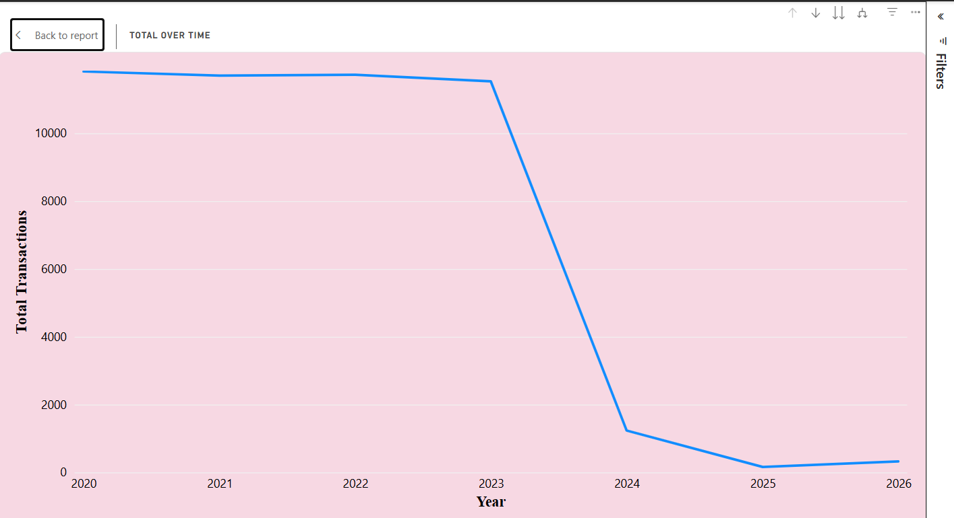
3. Transaction Summary
A table comparing Deposit, Withdrawal, Transfer, and Payment by transaction count or total amount makes it easier to compare transaction categories.
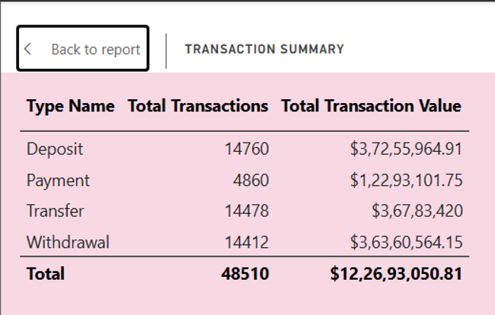
4. Transactions by Type
A clustered bar chart of total transaction and type can identify which type is used more or less.
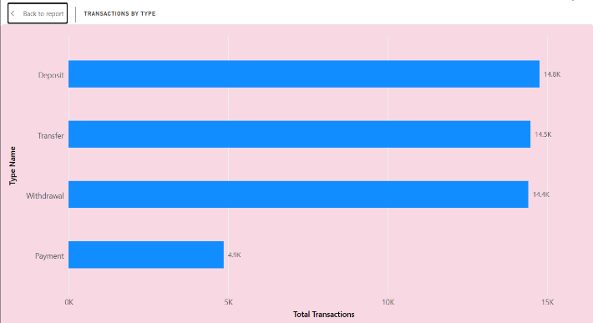
5. Account Balance by Account Type
A clustered bar or column chart can compare the number of accounts and total balance for Checking, Savings, Payroll, Business, and Youth accounts.
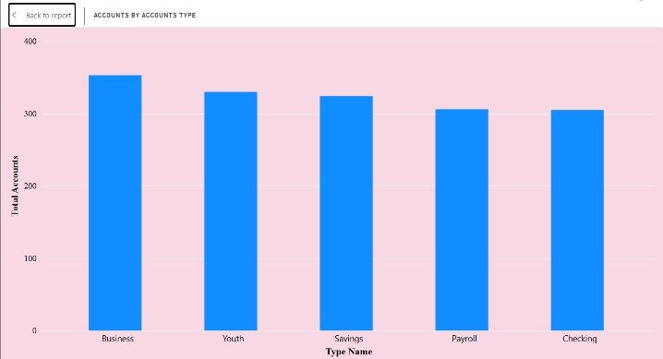
6. Customer Segments and Slicers
A chart can compare Individual, Small Business, and Large Enterprise customers. Slicers for year, transaction type and account type allow users to explore selected segments.
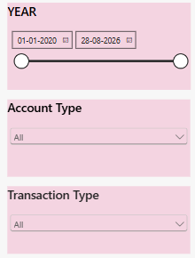
Key Findings
The following findings are calculated from the supplied CSV records and can guide the dashboard interpretation:
- The dataset is pretty big, with 50,000 transactions recorded. Altogether, they add up to about 125 million, and most individual transactions hover around 2,500 each.
- Deposits show up the most often, followed closely by transfers and withdrawals, while payments are less common.
- The records stretch across more than six years, from January 2020 to August 2026. A small chunk (about 1,000 transactions) doesn’t have dates, so those won’t show up in time-based charts unless fixed.
- There are 1,667 accounts in total. Business accounts are the largest group, but there are also Youth, Savings, Checking, and Payroll accounts. Most accounts are active, though some are inactive or closed.
- On the loan side, there are 333 loans worth about 17 million combined. Most are active, some are fully paid off, and a few are overdue. The average interest rate is just under 9%.
- The dataset also includes 1,111 customers and 50 branches, which means you can compare things across customer groups or branch locations.
Conclusion
This project provides practical experience in using Microsoft Power BI to analyse banking and financial data. By combining transaction, account, customer, branch, and loan tables, the dashboard can present an integrated view of financial activity and loan performance. KPI cards, time-series charts, category comparisons, detailed tables, and slicers make it easier to explore the data and identify patterns. Careful data preparation—especially reviewing missing dates and confirming relationships between account and transaction tables—is essential to ensure that the resulting visualizations are reliable and useful for decision-making.
References
- Microsoft Power BI Desktop.
- Dataset 4 — Financial Transactions and Loan Dataset
- Microsoft Power BI documentation.

